## **Objectives**

* Explain React Forms validation
* Identify the differences between React Form and HTML Form
* Explain about controlled components
* Identify various React Form input controls
* Explain how to handle React Forms
* Explain about submitting forms in React

In this hands-on lab, you will learn how to:

* Implement React forms validation
* Use various input controls like textbox, button and textarea

## **Prerequisites**

The following is required to complete this hands-on lab:

* Node.js
* NPM
* Visual Studio Code

## **Notes**

Estimated time to complete this lab: **60 minutes.**

Create a React App named “mailregisterapp” which will have a component named “register.js”. Create a form which accepts the name, email and password and validate the fields as per the following:

1. Name should have atleast 5 characters
2. Email should have @ and .
3. Password should have atleast 8 characters.

Ensure that validations are implemented through eventhandle and eventsubmit of a form.

**Output Expected:**

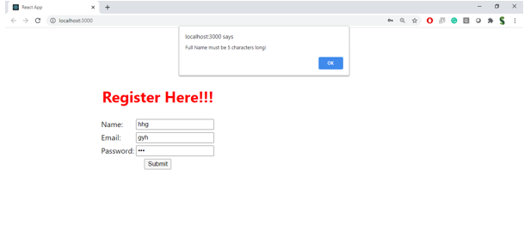

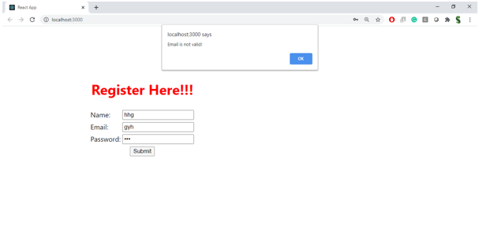

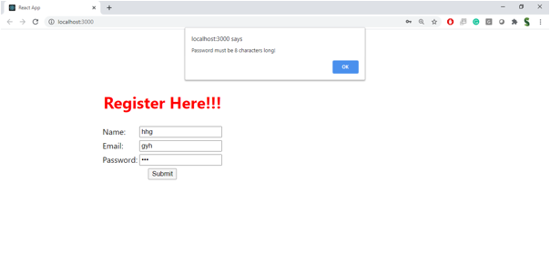

**Hint:**

